GUNSMOKE MINES
Game Design Document
Version 2.2 — Unreal Engine 5.6 build
Project title | Gunsmoke Mines
Document type | Game Design Document (GDD)
Unit | FGCT4017 – Fundamentals of Games Design
Programme | BA (Hons) Game Design, Level 4, UCA
Author | Bruno Mirone
Version | 2.2
Target platform | PC (Windows), keyboard & mouse
Target engine | Unreal Engine 5.6 — Blueprint-only, no C++
Perspective | Top-down 3D (fixed camera)
Companion document | Gunsmoke Mines — 2-Day Build Plan
Contents
1. Game Overview 3
2. Genre Positioning & Context (Situating) 3
3. Core Gameplay 3
3.1 Loop summary 4
4. Controls & Input 4
5. Story & Setting 4
6. Characters 4
6.1 Player — Jesse “Dust” Allister 5
6.2 Mobs — Bandits 5
6.3 Boss 5
7. Combat & Weapons 5
8. Win / Lose Conditions 6
9. UI & HUD 6
10. Art & Visual Style 6
11. Map Design 7
12. Powerups 8
13. Production Plan 8
14. Scope & Constraints 9
15. Build Scope (2-Day Prototype) 10
16. Revision History 11
17. References 11

1. Game Overview
Gunsmoke Mines is a top-down dungeon crawler set in a wild-west mining town, built in Unreal Engine 5.6 using Blueprints only. The player takes on the role of Jesse “Dust” Allister, a gunslinger hired by the Western Extermination Association (WEA) to descend through an infested mineshaft and eliminate a criminal group that has taken control of it. Along the way the player fights enemies, collects keys to unlock chests, and finds weapons, abilities, and powerups that support progression. The game is checkpoint-based, so a failed run does not erase overall progress, and it targets PC only.
The game is presented as top-down 3D rather than 2D: the world is built from 3D geometry and viewed through a fixed, downward-angled camera on a spring arm. This keeps the readability of a classic top-down layout while letting the project use Unreal’s standard character movement, navigation, and collision systems rather than working against them.
Target audience: players of top-down action-roguelites such as Hades and Hollow Knight, drawn to tight combat loops, build-defining pickups, and a strong sense of place and atmosphere.

2. Genre Positioning & Context (Situating)
Gunsmoke Mines borrows its moment-to-moment combat and run structure from Hades (dash-based mobility, checkpointed progression, escalating power through pickups) and its atmosphere and enemy pacing from Hollow Knight (a hostile, claustrophobic environment where every encounter carries weight). The western setting differentiates it from both: rather than a mythological underworld or an insect kingdom, the game reframes the descent as an industrial-era mine, letting weapon variety (rifles, revolvers, TNT) stand in for the ability/spell variety typical of the genre.
Representation note: bandit enemies and the framing of “extermination” lean on established western-genre tropes (outlaws, lawmen-for-hire). To avoid this reading as gratuitous violence for its own sake, character and enemy writing will keep the antagonists defined by their actions in-fiction (sabotage, theft, endangering miners) rather than by appearance or caricature, and will avoid drawing on real ethnic or cultural stereotypes associated with the genre’s less careful media (e.g. no exaggerated accents, no lazy Indigenous-American or Mexican caricatures in enemy design, despite these being common in genre media).
Professional context: the project follows industry-standard GDD conventions (systems before content, tunable numbers, explicit scope) so that, if extended beyond the unit, it could be handed to another designer or engineer without ambiguity. The accompanying Build Manual mirrors this by specifying the game as reusable systems — a shared health component, a weapon Data Table, an interaction interface — rather than as one-off scripted behaviours.

3. Core Gameplay
The player fights through a mineshaft, collecting keys that unlock chests containing weapons, abilities, and powerups, while surviving mob encounters. Progress is checkpoint-based: dying returns the player to the last checkpoint rather than the start of the run.
Core mechanics: dash (mobility/i-frames), melee attack, ranged weapon attack, and a thrown TNT explosive. All four are upgradeable through progression and levelling. The intended feel is a semi-fast-paced arcade shooter with enough variables (range falloff, enemy revive windows, checkpoint risk) to keep encounters challenging without being punishing.

3.1 Loop summary
Explore → fight mobs → collect keys → open chests → acquire weapons/powerups → reach checkpoint → repeat → boss.
Failure state: player death respawns at the last checkpoint with permanent powerups retained and temporary powerups lost.

4. Controls & Input
Primary input is keyboard & mouse, handled through Unreal’s Enhanced Input system (one Input Action asset per verb, bound through a single Input Mapping Context). Gamepad support is listed as a stretch goal and is out of scope for the current build; the mappings below are recorded so the control scheme is documented in full.
Action | Keyboard / Mouse | Gamepad (stretch goal)
Move | WASD | Left stick
Aim | Mouse position | Right stick
Dash | Space | B / Circle
Ranged attack (M1) | Left mouse button | Right trigger
Melee attack (M2) | Right mouse button | Left trigger
Throw TNT | Q | Left bumper
Reload | R | X / Square
Interact / open chest | E | A / Cross
Pause / menu | Esc | Start
Design note: a manual reload was added in v2.0. Weapons carry a fixed magazine (Section 7), so without a reload input the player is forced to dry-fire before the weapon refills — which removes the tactical decision of topping up between encounters.

5. Story & Setting
Gunsmoke Mines is set in a wild-west, early-1900s frontier town, evoking the tone of Red Dead Redemption. Jesse “Dust” Allister is contracted by the WEA after miners report that bandits have infiltrated the mine and rigged explosives beneath the town. Allister must descend, clear the threat, and disarm the situation before a timer expires and the mission fails.
Wild-west aesthetics run through the level design: a dark, sandy colour palette; period-accurate weapons (revolvers, sawed-off shotguns) in place of modern firearms; TNT instead of grenades. The overall tone is dark, sandy, and gritty, with eerie mine ambience (creaking supports, distant dripping, cave echoes) layered under gameplay to sustain tension between combat encounters.

6. Characters

6.1 Player — Jesse “Dust” Allister
A cowboy gunslinger designed to feel fast, agile, and tactical, while still reading as powerful and intelligent. Kit: dash, M1 (ranged attack), M2 (knife/melee attack), and a TNT throw on the grenade slot. Starting health is 100.

6.2 Mobs — Bandits
Bandits dressed in dark, weathered clothing, attacking with aggressive but unsophisticated AI — strong hits, no self-preservation. Mechanics: a dodge, an M1 attack, and a “knock” state — on taking lethal damage a bandit falls into a 15-second injured state; if not finished within that window, it revives at 10% HP. This rewards follow-through in fights rather than one attack and disengage. Starting health is 40.

6.3 Boss
Stationed at the base of the mine, guarded by elite bandits. Visibly larger with a substantially higher HP pool (600–800) and higher-tier clothing signalling wealth/status. Slower than standard bandits but hits far harder, with a four-move set: stomp (AoE), kick (knockback), punch (single-target burst), and knife stab (fast punish for melee range).

7. Combat & Weapons
Weapon damage and fire rate scale with the range band each weapon is designed around, so weapon choice is a positioning decision rather than a pure DPS race. All seven weapons are stored as rows in a single Data Table (DT_Weapons) so balancing is done by editing numbers, not Blueprint graphs.
Weapon | Type / Reload | Range | Damage (Long / Med / Short) | Fire Rate
Sniper Rifle | Bolt-action, 1 BPR | Long | 100 / 40 / 0 | 1 shot / 3.5s
High-Profile Revolver | 6 BPR | Med–Long | 60 / 50 / 20 | ~1 shot / 0.8s
Basic Revolver | 6 BPR | Med–Long | 50 / 40 / 15 | ~1 shot / 0.8s
Pistolero | 10 BPR | Short–Med | 10 / 40 / 80 | ~2 shots / s
Throwing Knife | Recoverable after use | Short–Med | 5 / 30 / 60 | 1 throw / 1.2s
TNT | Timer-based (cooldown) | Med (AoE) | 0 / 60 / 90 (blast radius) | Cooldown-based
Sawed-Off Shotgun | 2 BPR | Short | 0 / 10–50 / 100 | 2 shots / s, then 2s reload
Range bands are defined in world units (Unreal centimetres): Short is up to 300, Medium up to 700, Long up to 1500. A shot beyond 1500 does not connect.
Mob loadouts are randomly assigned from basic revolver, pistolero, or throwing knife. Weapon stats (damage, reload speed, range band) can be temporarily buffed by powerups (Section 12).
Design rationale: range-based falloff (rather than flat damage) is intended to make positioning the primary skill expression in combat — the shotgun rewards aggression, the sniper rewards spacing, and the pistolero sits as a flexible default. These figures are a starting balance pass and are expected to change during the iteration phase (Section 13) once playtested.

8. Win / Lose Conditions
- Win: reach the bottom of the mine, defeat the boss, and disarm the town before the mission timer expires.
- Lose (run): player HP reaches 0 — respawn at the last checkpoint, temporary powerups lost, permanent powerups retained, keys/chests already opened stay opened. This is a soft fail.
- Lose (mission): the town timer reaches 0 before the boss is defeated — hard fail state, showing a mission-failed screen with a retry prompt.
The mission timer only begins counting once the final descent is entered, so the exploration and combat sections earlier in the mine are untimed. This keeps the timer as a climax-pressure device rather than a constraint on the whole run.

9. UI & HUD
- Health bar (top-left), styled as worn leather/metal to match the pixel-art aesthetic.
- Ammo / reload indicator next to the equipped weapon icon, showing rounds remaining and a reloading state.
- TNT cooldown indicator, shown as a radial fill. UMG has no built-in radial progress bar, so this is a material-driven element in the art pass; the systems build uses a linear bar in its place.
- Key count and mission timer (top-right), the latter only visible once the final descent begins.
- Active powerup icons with a countdown ring for temporary effects (same material-driven approach as the TNT indicator); permanent powerups shown as a fixed row with no timer.
- Checkpoint reached notification (brief, non-blocking toast).
- Boss health bar, shown along the bottom of the screen only while the boss encounter is active.
- Pause menu (Esc): resume, restart from last checkpoint, quit.

10. Art & Visual Style
The world is 3D — modular mine geometry, props, and characters — lit and rendered in Unreal, and viewed from a fixed top-down camera. The retro character of the game is carried by a semi-pixel-art treatment of the interface layer: HUD elements, item icons, and the powerup cards (Section 12) are authored as pixel art, sitting over the 3D scene. This split keeps the retro feel while playing to what Unreal does well and keeping the 3D asset workload low.
The palette is dark and sandy — beige and maroon tones — chosen to evoke the leather and dust of wild-west aesthetics. Lighting leans on warm point and spot lights (lanterns, lamps) against near-black cave shadow to sell depth in a top-down view, where a flat ambient wash would read as featureless.
Audio direction follows the same reference: “high noon” western scoring, built around the reverb-heavy guitar tone commonly associated with the genre, to keep the atmosphere coherent with the visual and narrative direction.

11. Map Design
The mine is built as a single continuous Unreal level rather than procedurally-generated separate floors. This keeps progression as one uninterrupted line of play and lets the powerup system (Section 12) function cleanly, since temporary powerups are tied to the current run segment. Structurally the level is closer to a roguelite with fixed checkpoints than a traditional roguelike with permadeath.
The level is assembled from a small reusable kit of modular static meshes (corridor, junction, cavern, prop set) rather than bespoke geometry per room, so one person can build the full descent. A Nav Mesh Bounds Volume covers the playable space to drive bandit and boss navigation.
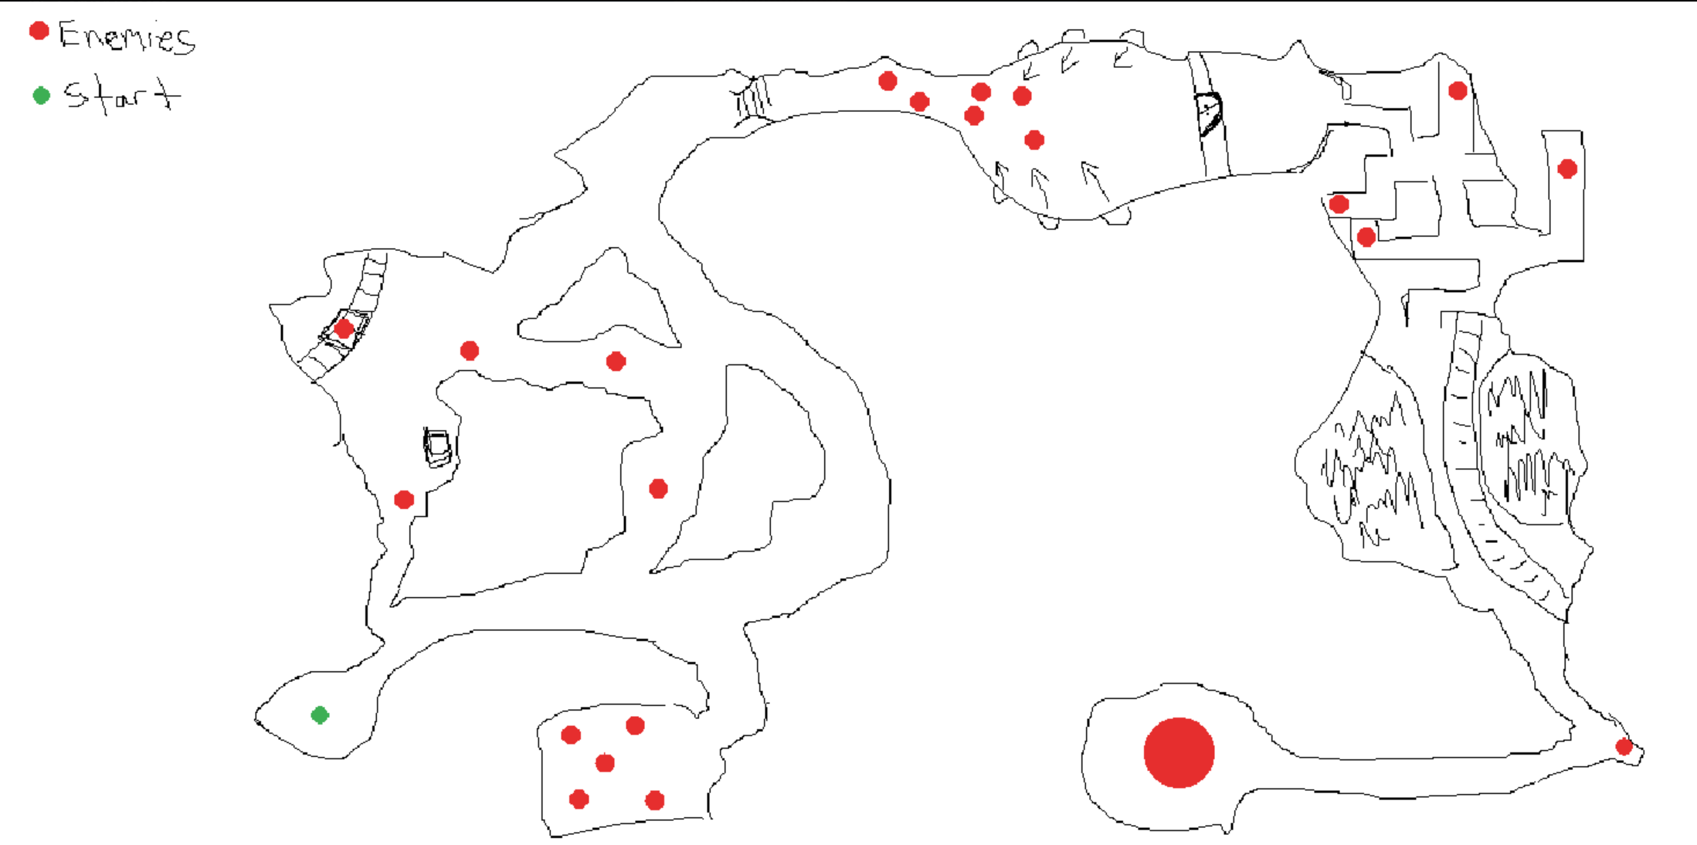
Fig. A — hand-drawn layout sketch: critical path, branching combat rooms, start point (green) and enemy placement (red), with the boss arena bottom-right.
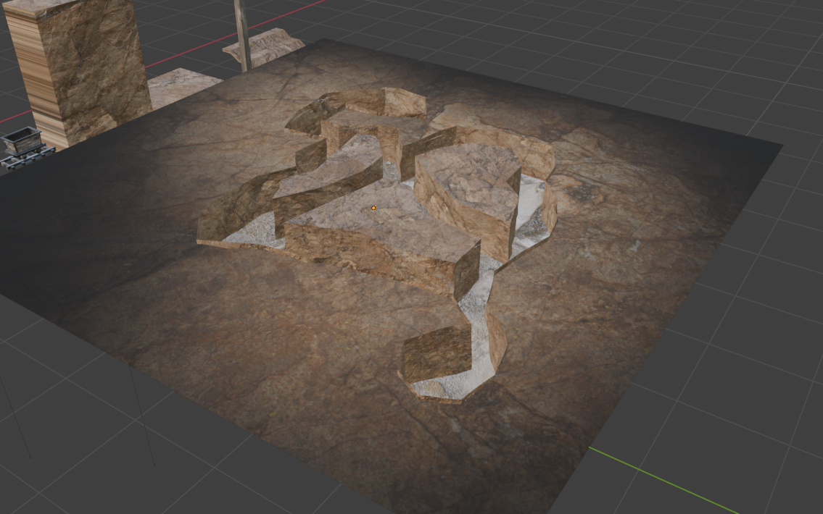
Fig. B — early 3D blockout of a mine section, used as a reference for tone, scale and corridor width before building in-engine.

12. Powerups
Two powerup tiers exist. Temporary powerups (black border) last one minute and cover five categories spanning strength to speed — these are meant to create short bursts of build variety within a single encounter, and are lost on death. Permanent powerups (“legendary”) persist until the run ends, with no time limit, and represent the main long-term progression hook within a run.
Powerup | Tier | Duration |  | Effect
Bloody Heal | Temporary | 60s |  | Gain HP on kill for the duration
Speed Surge | Temporary | 60s |  | Movement speed up, dash cooldown reduced
Iron Skin | Temporary | 60s |  | Flat damage reduction on incoming hits
Overcharge | Temporary | 60s |  | Fire rate increased
Adrenaline | Temporary | 60s |  | Melee damage increased
Alchemist | Permanent | — |  | Attacks apply stacking poison damage over time
Deadeye | Permanent | — |  | Permanent ranged damage increase
Second Wind | Permanent | — |  | One automatic revive per run at 30% HP
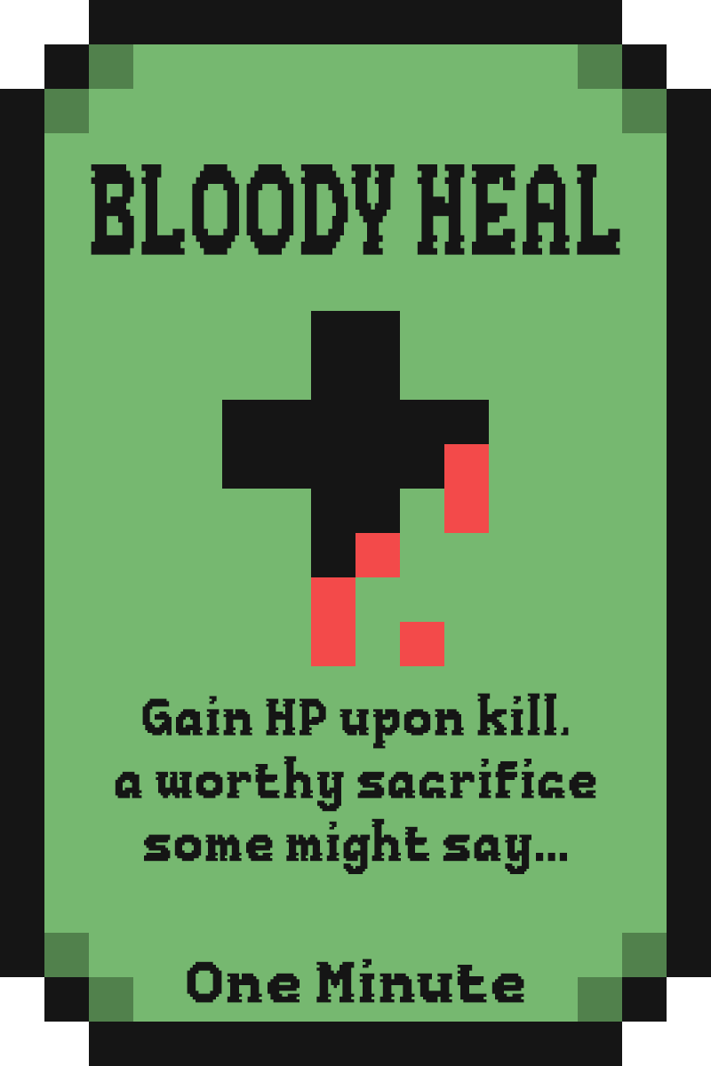  Fig. C — Temporary powerup card (black border, duration stated). |  |  | 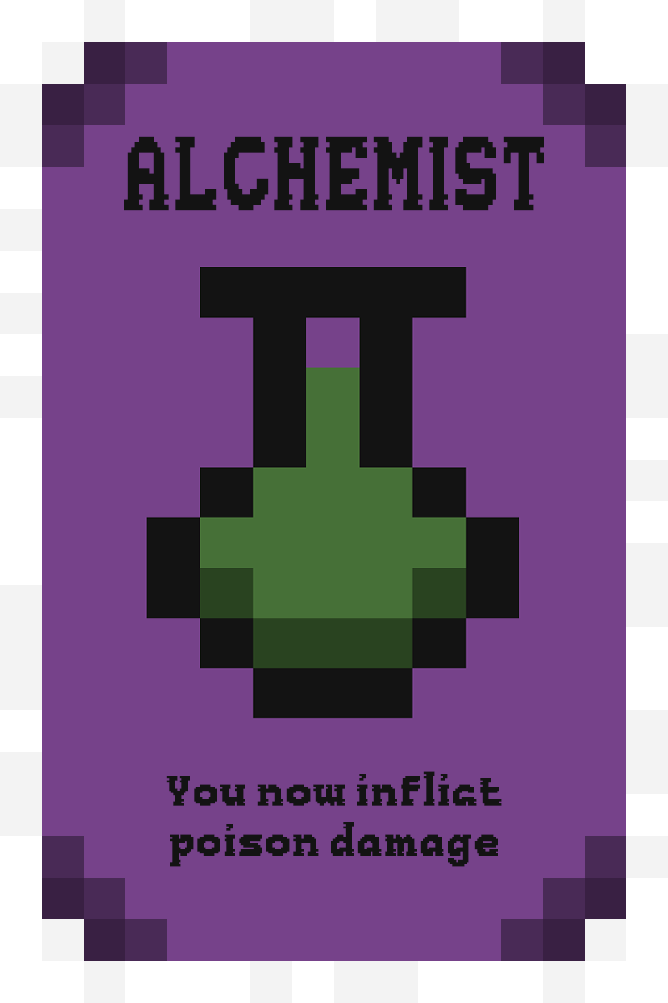  Fig. D — Permanent “legendary” powerup card (no duration stated).

13. Production Plan
The project is planned as a sequence of phases rather than fixed dates, moving from research and pre-production through core-loop prototyping, systems completion, and final polish. The build phases map directly onto the parts of the companion Build Manual, so progress against this plan is measurable.
Phase | Focus | Key output
Pre-production | Research & foundations: MDA framework, genre analysis (Hades, Hollow Knight), UE 5.6 project setup | Research notes, project scaffold (Manual Parts 1–2)
Design pass | GDD drafting, level layout sketch, Enhanced Input, core movement + dash | GDD v2.0 (this document), playable movement (Parts 3–4)
Combat prototyping | Health/damage component, melee, ranged, hit feedback | Playable combat loop (Parts 5–7)
Weapon & AI pass | Weapon Data Table, damage/range tuning, bandit AI and knock/revive | Tuned weapon set, working enemy (Parts 6, 9)
Core loop polish | Interaction system, checkpoints, keys and chests | Playable vertical slice (Parts 8, 11–12)
Boss design | Boss Behavior Tree and four-move encounter | Boss encounter v1 (Part 10)
Systems completion | Powerup system (temporary + permanent), HUD, win/lose | Full core loop start-to-finish (Parts 13–15)
Art & audio pass | Modular mine kit, pixel-art UI, western SFX/music, VFX | Visual/audio polish
Balancing | Bug-fixing, playtesting, dev log write-up | Stable build, near-final dev log
Finalisation | Showcase video production, final documentation | Final submission-ready build

14. Scope & Constraints
As a single-developer project, scope has been deliberately kept tight and achievable. The following constraints define the build:
- Blueprint-only implementation — no C++. Every system in the Build Manual is achievable with Blueprint visual scripting, which keeps the project buildable without a programming background and keeps iteration inside the editor.
- Single continuous level, no additional biomes — a deliberate design choice that keeps progression as one uninterrupted line of play and keeps the level buildable by one person.
- Enemy roster limited to one bandit type plus the boss, keeping AI work and art asset count manageable without diluting the design’s clarity.
- Seven weapons as outlined in Section 7, prioritising data and balancing depth over raw content volume. VFX per weapon are shared (muzzle-flash and impact effects reskinned per weapon) to keep the art workload realistic.
- Art pipeline relies on a limited, reusable modular mesh and prop kit, plus Unreal Starter Content and placeholder primitives during the systems build, supplemented by AI-assisted image generation for concept and reference art (logged as reference only, not shipped assets, in the development log).
- Audio sourced from royalty-free western-genre packs and lightly edited rather than composed from scratch.
- Gamepad support, character animation beyond placeholder states, additional dialogue and voice-over, and a save-file/meta-progression system are explicitly out of scope for the current build and listed here as stretch goals only. Progress within a run is held in the Game Instance and is not written to disk.

15. Build Scope (2-Day Prototype)
This document describes the complete design. The prototype built for submission implements a deliberately reduced subset of it, scoped to a two-day single-developer build in Blueprints and set out step by step in the companion 2-Day Build Plan. The reduction is a scoping decision, not an omission: what is kept is what carries the core loop end to end, and what is cut is either a variation on a pattern the prototype already demonstrates, or a system whose absence does not stop the game being played from start to finish.
Design element | In the prototype | Reasoning
Movement, aim, dash with i-frames | Full | The moment-to-moment feel described in Section 3 depends entirely on these.
Weapons | 1 of 7 (revolver) | One weapon demonstrates the shooting system. Six more are data entry, and the Data Table that would manage them is dropped with them.
Range-banded damage | Cut (stretch) | Section 7 identifies positioning as the primary skill expression, so this is the first thing to restore if time allows — it is three additional nodes.
Ammo and reloading | Cut | A full state machine and a HUD element for no change to the core loop.
Melee attack, TNT | Cut (stretch) | Neither is needed to complete a run. Melee is the second thing to restore if time allows.
Bandit AI | Chase and attack | Written as plain Blueprint on a repeating timer rather than a Behavior Tree. At one enemy type the visible behaviour is identical.
Bandit knock / revive | Cut (stretch) | The most distinctive enemy mechanic in Section 6.2, and also the most intricate. Recipe retained in the Build Plan.
Boss | 1 of 4 moves | A large health pool and heavy hits establish the encounter. The remaining three moves repeat the same work.
Keys, chests, checkpoints | Full, simplified | The loop in Section 3.1 is kept intact. Chests open on contact rather than on an interact key, which removes an interaction system without changing what the player does.
Powerups | 1 of 8 (Deadeye) | One permanent powerup demonstrates the system. The temporary tier is a stretch item.
Mission timer and hard fail | Cut | Section 8's soft fail (respawn at checkpoint) is implemented; the timed hard fail is not. The run ends on the boss's death.
HUD | Health and keys | Ammo, TNT cooldown, timer and powerup icons all follow the systems they belong to.
Pause menu, boss health bar | Cut | Neither affects whether the game can be played start to finish.
Art, animation, audio | Placeholder only | Grey-box geometry and primitive shapes throughout, per Section 14.
Total build: eleven Blueprints and one level. The gap between that and the full design above is the scope decision this section records.

16. Revision History
Version | Date | Changes
1.0 | — | Initial GDD. Target engine recorded as Godot 4 (2D top-down).
2.0 | August 2026 | Retargeted to Unreal Engine 5.6, Blueprint-only, top-down 3D. Added Blueprint-only constraint (S14), reload control (S4), explicit range-band distances and DT_Weapons reference (S7), named powerup roster (S12), boss health bar and pause menu (S9), modular mesh kit and Nav Mesh note (S11), production phases mapped to Build Manual parts (S13). Corrected swapped Fig. A / Fig. B captions.
2.1 | August 2026 | Added Section 15, recording the reduced scope of the prototype against the full design.
2.2 | August 2026 | Section 15 rescoped from a five-day to a two-day Blueprint-only build. Design content in Sections 1–14 unchanged.

17. References
Genre references: Supergiant Games, Hades (2020); Team Cherry, Hollow Knight (2017); Rockstar Games, Red Dead Redemption (2018).
Technical references: Epic Games, Unreal Engine 5.6 Documentation — Enhanced Input, Behavior Trees and StateTree, Data Tables, UMG UI Designer.

